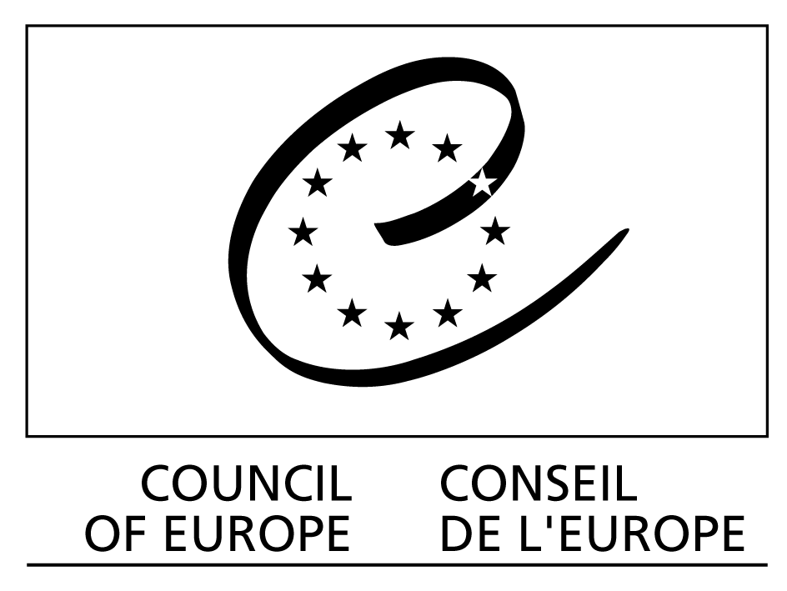

Republic of Croatia
Ministry of Family, Veterans’ Affairs
and Intergenerational Solidarity

European High Level Conference on the
Council of Europe Disability Action Plan 2006-2015:
National Implementation – from Policy to Practice

organised under the auspices of the Government of the Republic of Croatia
in co-operation with the
Council of Europe Directorate General for Social Cohesion and the
Ministry of Family, Veterans' Affairs and Intergenerational Solidarity

Zagreb Declaration

21 September 2007

Zagreb, Republic of Croatia, 20-21 September 2007

European High Level Conference on the
Council of Europe Disability Action Plan 2006-2015:
National implementation – from Policy to Practice

Zagreb, Republic of Croatia, 20-21 September 2007

ZAGREB DECLARATION

1. We, the representatives of Ministries responsible for integration policies and the protection of rights of people with disabilities of Albania, Austria, Bosnia and Herzegovina, Bulgaria, Croatia, Italy, Moldova, Romania, Serbia, Slovenia, “the former Yugoslav Republic of Macedonia”, Turkey, and Ukraine, gathering in Zagreb, Republic of Croatia, on 20-21 September 2007, together with representatives of the European Co-ordination Forum for the Council of Europe Disability Action Plan (CAHPAH), as well as international organisations and NGOs, to promote Recommendation Rec(2006)5 of the Committee of Ministers to member states on the Council of Europe Action Plan to promote the rights and full participation of people with disabilities in society: improving the quality of life of people with disabilities in Europe 2006-2015;

2. taking due account of relevant existing European and international instruments, treaties and plans, particularly the Convention for the Protection of Human Rights and Fundamental Freedoms (ETS No. 5) and the revised European Social Charter (ETS No. 163);

3. following the Political Declaration adopted at the Second European Conference of Ministers responsible for integration policies for people with disabilities “Improving the quality of life of people with disabilities: enhancing a coherent policy for and through full participation”, Malaga, Spain, May 2003, and the Contribution of the European Disability Movement to that Conference ;

4. having regard to the Action Plan of the Third Summit of Heads of State and Government of the Council of Europe (CM(2005)80 final), adopted in Warsaw on 17 May 2005, which lays down the role and main responsibilities of the Council of Europe in the coming years;

5. having regard to the St. Petersburg Declaration adopted on 22 September 2006 at the European Conference on “Improving the quality of life of people with disabilities in Europe: participation for all, innovation, effectiveness”;

6. welcoming the adoption by the United Nations General Assembly of the Convention on the rights of persons with disabilities, the signature and stimulation of its ratification, which have been initiated by a number of European member states, and the possibility to use the Council of Europe Disability Action Plan as a European regional operational instrument to help member states in meeting their commitments in relation to the United Nations Convention, in particular Article 33;

7. fully share the fundamental principles and strategic goals of the Council of Europe Disability Action Plan aimed at strengthening the efforts and commitment of member states to work within anti-discriminatory and human rights frameworks to enhance independence, freedom of choice and the quality of life of people with disabilities and to raise awareness of disability as a part of human diversity;

8. take due account of the complexity of this major task and welcome the holistic approach of the Council of Europe Disability Action Plan, which recommends specific actions in 15 key action lines, thus covering all areas of life of people with disabilities, from participation in political and cultural life via education, vocational training, employment, accessibility, transport, information and communication, to health care, rehabilitation, social and legal protection as well as community living, independent living, research or awareness-raising;

9. acknowledge the fact that implementation of the Council of Europe Disability Action Plan is primarily the responsibility of the member states, and that the respect towards the international obligations is an honorable duty of any member state;

10. call upon all Council of Europe member states to adopt a strategic and comprehensive approach to policies for persons with disabilities by implementing the Council of Europe Disability Action Plan, and invite the Council of Europe member states to take note of this Declaration and its practical recommendations;

11. recall, first and foremost, that, as stated in the Recommendation Rec(2006)5, member states, when implementing the specific actions contained within the Council of Europe Disability Action Plan, will take full account of:

- the principles underpinning the Action Plan, including in particular the rights of individuals to protection against discrimination, to equal opportunities and to the respect of their rights as citizens;

- cross-cutting aspects including the specific needs of women and girls with disabilities, children and young people with disabilities, people with disabilities in need of a high level of support, ageing people with disabilities, migrants with disabilities and people with disabilities from minorities, in addition to the crucial role that quality services and training play in relation to the provision of services to people with disabilities;

- the need to provide support to families of persons with disabilities with the goal of full and equal participation in all areas of community living;

- the involvement of NGOs, in particular representative disability organisations, in all stages of implementation, monitoring and evaluation at European, national, regional and local levels, as well as insuring their sustainability as organisations of particular interest to promote diversity through the financing of their basic line of activity, considering that extra costs for participation are the first barrier that people with disabilities face;

- the employment of persons with disabilities within the public sector as an essential step in the change of practice;

- the goal of alleviating the negative impact of poverty on persons with disabilities.

12. acknowledge that people with disabilities are citizens with extremely diverse needs and possibilities and faced with different barriers, and, therefore, recommend that comprehensive action plans are developed taking into account this diversity;

13. noting that the governments of the member states have the responsibility for implementing the specific actions under each action line, recall that the Recommendation Rec(2006)5 invites the governments to start with an evaluation of their existing disability policy programmes and underlying basic principles against the blueprint of the Council of Europe Disability Action Plan to identify in which areas progress has yet to be made and which specific actions will have to be carried out;

14. recommend that member states study and identify the compliance gap with the expertise of people who face discrimination on the basis of their disability, and namely, how formal laws and policies as well as regional and local regulations interface with the social practices of those laws, policies and regulations, and how effectively formal texts are implemented;

15. acknowledge the fact that the prioritisation and the establishment of a timetable to progress measures adopted, as well as the streamlining of all efforts to improve resource allocation for the implementation of the Council of Europe Disability Action Plan, are the responsibilities of each member state;

16. recommend, therefore, that relevant public authorities in the member states of the Council of Europe create national strategies and implementation mechanisms towards the achievement of the goals stated in the Council of Europe Disability Action Plan, including, in particular, the provision of appropriate financial and human capital, to enable significant progress;

17. recommend that member states bridge policy and practice by empowering policy makers and practitioners at all levels to set up and develop sustainable programmes to advance in the implementation of the Council of Europe Disability Action Plan;

18. recommend that member states encourage innovative approaches and methods that identify the barriers faced by people with disabilities in their daily lives with the objective to remove obstacles which limit the free choice of lifestyle and of the place to live, in particular, those that allow identifying, learning from, comparing, appraising, and disseminating successful practice with an emphasis on attitudinal change;

19. strongly recommend supporting initiatives promoting the acceptance within societies at large of the significance and importance of full inclusion of people with disabilities, especially in the process of building more cohesive and just societies in Europe, promoting meaningful participation and the feeling of worth;

20. recommend that member states proceed towards the implementation of the Council of Europe Disability Action Plan with an effective co-ordination based on clear distribution of responsibilities with regard to the recommended specific actions. We are also convinced that disability policies should no longer be seen as solely the responsibility of a specific ministry or department. It is the responsibility of all ministries to ensure that their initiatives take into account the rights of persons with disabilities. As stated in the Recommendation Rec(2006)5, co-ordination across and between government sectors and the creation of a focal point for all disability issues should be promoted to enhance and develop the mainstream approach;

21. recommend that member states move gradually to mainstreaming or sector responsibility. We are convinced that mainstreaming goes even further in reaching the objectives of inclusion and participation of people with disabilities – it involves the integration of services for people with disabilities with those for other citizens. The goal is to move away from policies which support segregation towards integration in the mainstream wherever possible, keeping in mind that, as stressed in Recommendation Rec(2006)5, mainstreaming does not preclude the existence of disability-specific policies, where they are in the best interests of persons with disabilities. People with disabilities should have access to mainstream health, education, vocational and social services and all the opportunities, which are available to non-disabled persons;

22. recommend encouraging multidisciplinary and transversal action involving all key stakeholders aiming at sustainable partnership between international organisations, member states authorities, local administration and representatives of civil society of and for people with disabilities, putting people with disabilities on equal footing with other stakeholders, in particular, through public procurement policies and involvement in political decision-making on matters relevant to people with disabilities;

23. strongly recommend that governments strive to improve communication and information sharing with specific focus on the collection, referencing and dissemination of know-how and successful practice in improving the quality of life of people with disabilities in order to lay the foundations for building a strong evidence base to inform decision-making;

24. advise member states to systematically raise awareness of the needs of people with disabilities amongst all professions that may affect the lives of people with disabilities, and, in coordination with disability organisations, to develop a variety of tools for use by different stakeholders together with quality indicators and assessment frameworks and to disseminate these tools accompanied with examples of successful practice of participation and social inclusion;

25. also recommend that member states encourage initiatives which develop new approaches towards improving the quality of life and the possibility of independent living of all persons with disabilities regardless of their condition, including through the use of new information and communication technologies, the provision of appropriate support and qualified services, including assistive devices, the application of reasonable accommodation and the Universal Design concept;

26. welcome the timely initiatives in member states aimed at the implementation of the Council of Europe Disability Action Plan mentioned in the plenary session of this Conference, and the recommendations resulting from debates held in the working sessions, and invite governments of all Council of Europe member states to take due account of these recommendations;

27. finally, recommend that the Council of Europe contributes in the framework of the Council of Europe Disability Action Plan and all its other relevant activities to strengthening inter-institutional and inter-sectorial co-operation to promote the rights and full participation of people with disabilities in Europe in order to achieve that Europe becomes a continent where all people with disabilities are fully integrated and included into society.

28. The following specific recommendations were developed in the workshops of the conference:

i. Implementation of the Council of Europe Disability Action Plan 2006-2015 into national strategies and national legislation

Every stocktaking exercise in member states should be followed by a coherent strategy or action plan for implementation, ensuring a periodic review within the framework of the Council of Europe Disability Action Plan, taking due account of the need for awareness raising and training of all stakeholders, including non-governmental organisations as well as government at regional and local level.

ii. Examples of good practices in participating states and implementation of national strategies

Acknowledging the importance of exchanging experiences and best practices as a vital tool for innovation and breaking new ground in the disability field, member states as well as representatives of civil society, in particular non-governmental organisations of people with disabilities, should strengthen co-operation and networking that will allow for the widest possible dissemination of good practices amongst all stakeholders.

iii. Forms of development of regional and international co-operation

Bodies for monitoring the implementation of the Council of Europe Disability Action Plan should be set up in those member states in which they do not already exist. Such bodies should, inter alia, provide information to the European Co-ordination Forum for the Council of Europe Disability Action Plan 2006-2015 (CAHPAH) on the realisation of national priorities and on definitions of disability and persons with disabilities.

iv. Co-operation of NGOs with state institutions and local governments

The structure, competence and working methods of the bodies for monitoring the implementation of the Council of Europe Disability Action Plan at national level should reflect the partnership between the disability movement and the competent authorities in the implementation of this Plan.

Full title: Contribution of the European Disability Movement to the Second European Conference of Ministers responsible for integration policies for people with disabilities

